[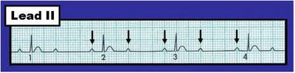](http://2.bp.blogspot.com/-nJlKLgc5FVk/TcbnR6rNSBI/AAAAAAAAAE8/uh09dohn3aM/s1600/ECG+%2523239-2-to-1-AV+block+%25285-8.22-2011%2529.jpg)