

THIS IS TO CERTIFY THAT

______________________________________________________

completed:

ACLS Prep Review Course
Enduring Material
On <Date>

This activity has been planned and implemented in accordance with the accreditation requirements and policies of the Accreditation Council for Continuing Medical Education (ACCME) through the joint providership of Prairie/HSHS, Prairie Education and Research Cooperative and ECGcourse.com, LLC. Prairie/HSHS is accredited by the ACCME to provide continuing medical education for physicians.

Prairie/HSHS designates this educational activity for a maximum of 3 AMA PRA Category I Credits ™. Physicians should only claim credit commensurate with the extent of their participation in the activity.

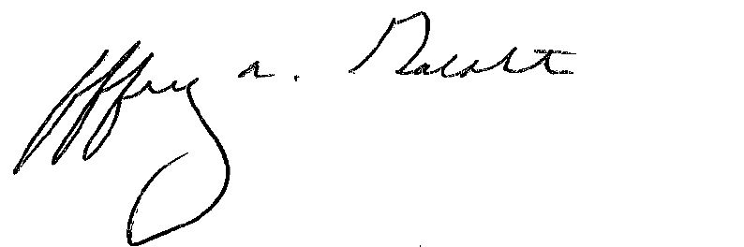
_________________________
Jeffrey A. Goldstein, M.D.
Medical Director,
Continuing Medical Education
Prairie Cardiovascular Consultants, Ltd.

